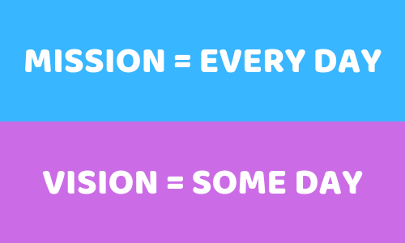

**Mission and Vision**

The mission statement focuses on today and what the organization does. The mission statement for a company defines it’s ‘reason for existing’ what do we do, how do we do it, whom do we do it for, what value are we bringing. The vision statement focuses on tomorrow and what the organization wants to become. Mission statement defines the company business, its objective and approach to reach the vision. Vision statement is an inspiring description of what you would like to achieve in the long-term future. Both are important to a company’s survival. Elements of **mission and vision** statements are often combined to provide a statement of the company’s purposes, goals and values. For most large organizations the idea of a ‘mission’ and a ‘vision’ are inextricably linked, with the ‘mission’ describing the ‘core’ of the center of a company, while the ‘vision’ shows where it is going – its strategic targets.

|  |  |  |
| --- | --- | --- |
|  | **Mission Statement** | **Vision Statement** |
| **Meaning** | A statement that describes that company’s objectives and its approach to reach those objectives. | A short statement that depicts the company’s aspiration for the future position of the company. |
| **What it is?** | Cause | Effect |
| **Talks about** | Present | Future |
| **Shows** | Where we are at present? | Where we want to be? |
| **Term** | Short term | Long term |
| **Purpose** | To inform | To inspire |

**Some examples of mission and vision statements**

**Tesla Motors Mission:** To accelerate the world’s transition to sustainable transport.

**Tesla Motors Vision:** To create the most compelling car company of the 21st century by driving the world’s transition to electric vehicles.

**Amazon Mission:** We Strive to offer our customers the lowest possible prices, the best available selection and the utmost convenience.

**Amazon Vision:** To be earth’s most customer centric company where customers can find and discover anything they might want to buy online.

**Google Mission:** Organizing the world’s information.

**Google Vision:** To provide access to the world’s information in one click.

**Facebook Mission:** To give people the power to share and make the world more open and connected.

**Facebook Vision:** People use Facebook to stay connected with friends and family, to discover what’s going on in the world, and to share and express what matters to them.

**Intel Vision:** If it is smart and connected. It is best with Intel.

**Nike Mission:** To bring inspiration and innovation for every athlete in the world.

**Summary**

* Where do you want to go? – **Vision**
* Why do you want to go? – **Mission**
* How will you get there? – **Action Plan**
* Core values – **Belief/Behavior**